[User Documentation: The Great Audio Race]
[Created by: That1Group]
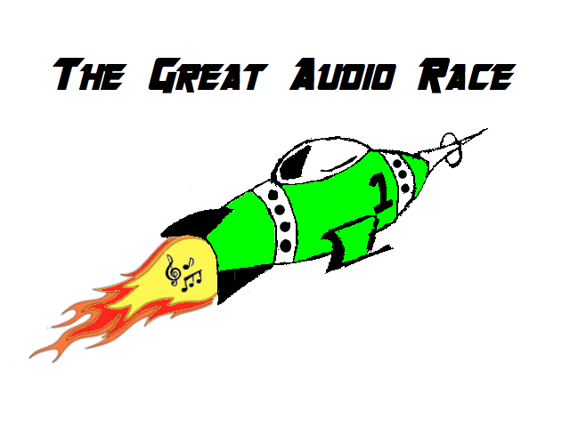
That1Group:
Brandon Scott, Taran Pennebacker, Andrew Rauh, Andrew Lees
Engineering 100.650
The Great Audio Race

Table of Contents
Page 3: System Requirements
Page 4: Main Menu

System Requirements

The optimal platform to be running to play this game is a Windows machine with complete optimization coming from the operating system Windows 7, although you can play on a Macintosh machine if necessary. To install The Great Audio Race make sure to have the entire zip folder downloaded and that every file within the zip folder is in your src folder of a project within Eclipse. Once this is completed, open the file named MainGame.py. Once you have done this, click the green “play” button at the top of your task bar within Eclipse, and the game should run successfully.

This document is intended for those who plan to be setting up the game for the user, a teenager with Autism Spectrum Disorder, to play. This includes, but is not limited too: therapists, doctors, parents, developers, testers, and the user themselves.

The purpose of this document is to provide a clean explanation of what The Great Audio Race is and how to play it. Also, this document is to provide detailed information about the making of the game, as well as the process behind the creation of the game. This game is rated E for everyone, so there is no required age for the reading of this document.

[Main Menu]
Summary:
This is the screen that will be seen originally at the start up of the game. It has four buttons on it that include: Play, Exit, High Scores, and Settings. Each tab leads to a new screen within the game. If the Play button is clicked, the player is brought directly to the screen in-order to begin playing The Great Audio Race. If the High Score button is clicked, the player will be directed to the screen to see all of the top scores of that player on the local machine they are playing on. If the Settings button is clicked, the user will be brought to a screen that allows them to customize the game thoroughly. Finally, if the Exit button is clicked the user will exit from the game.

Detailed Information:
The Main Menu is a file of it’s own that is called upon by the MainGame.py file. When the screen is brought up there are four working and visible options for the user to choose from. The can choose between Settings, Play, High Score, and Exit. If each of these menus are selected the user will be moved to a different screen and continue to navigate throughout the game accordingly.
As a player clicks the High Scores menu they will be brought to a screen (pictured on page 5) with a list of players that have successfully finished the game along with their score within the game. At first, if they clicked it when they first opened the game, they would see no names because no user finished the game at that point in time. As the user finishes songs and earns points a top ten list will be provided on the screen. This will include the users initials as well as the score that they received in game.
As the player clicks the Play button then would be brought to a screen (pictured on page 5) that will generate a map based on the song they have selected. They will then begin to the play the game until they have successfully finished the song.
As the player clicks the Settings button they will be brought to a screen (pictured on page 5) with a list of customizable options for them to select from. They can select the difficulty of their game, this being the speed of the game, the amount of obstacles, as well as life total. They can also change the menu colors from the original green color that we have provided for them, and they can also change the color of the rocket ship, changed from the color that is provided at the current time. This will allow for full customization to make the user feel much more comfortable while playing The Great Audio Race.

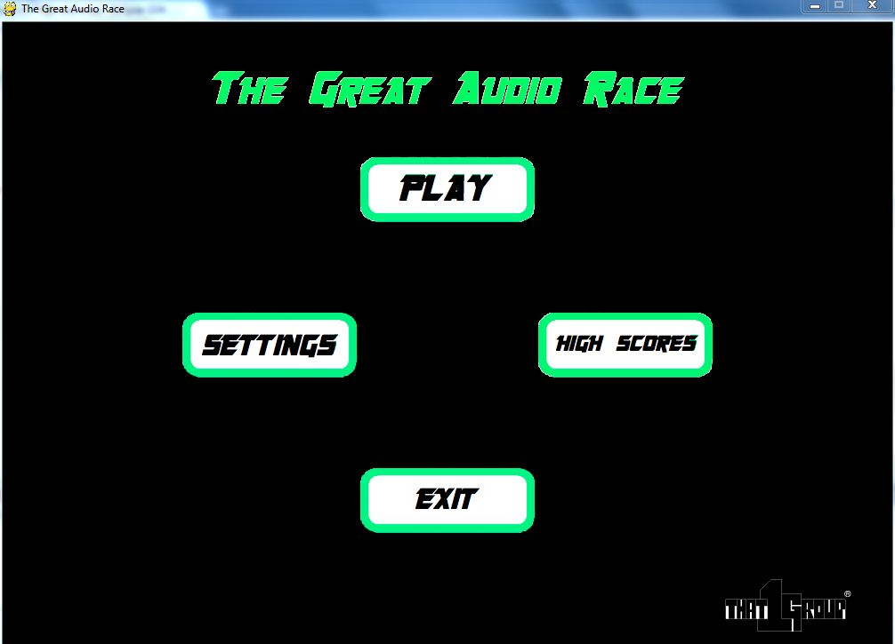
[Current Main Menu screen shot.]
[Graphics of Clicked Buttons]
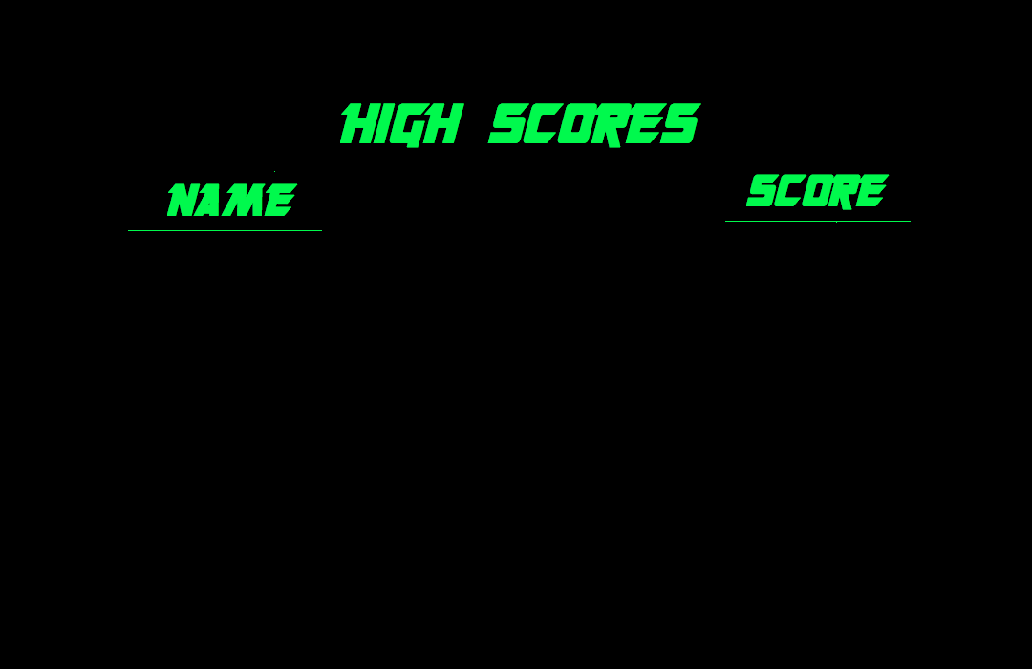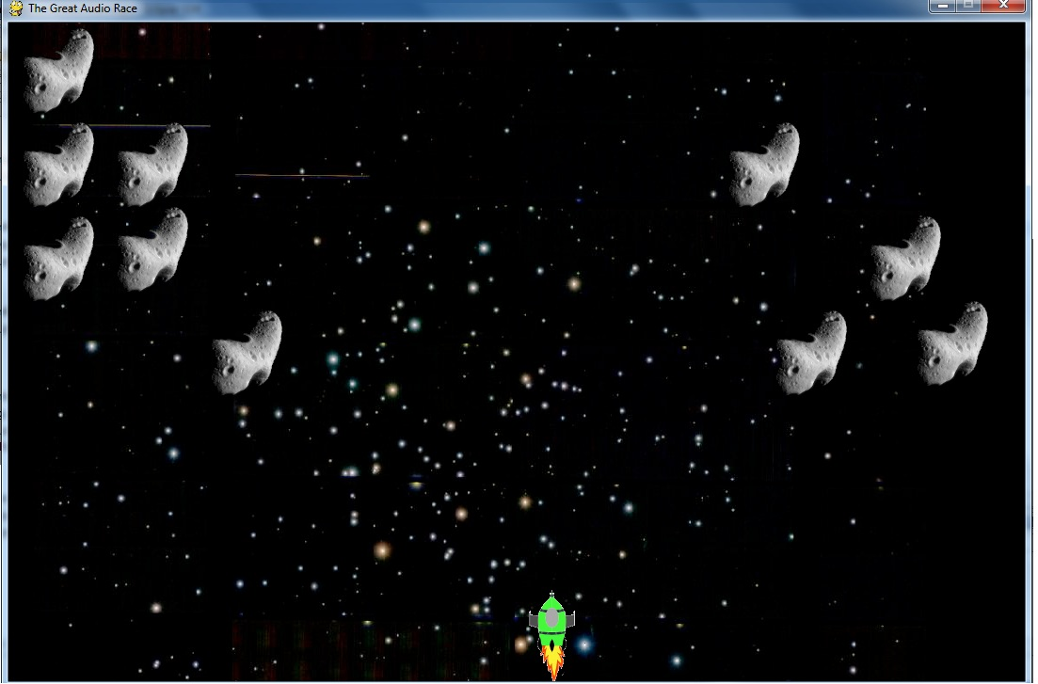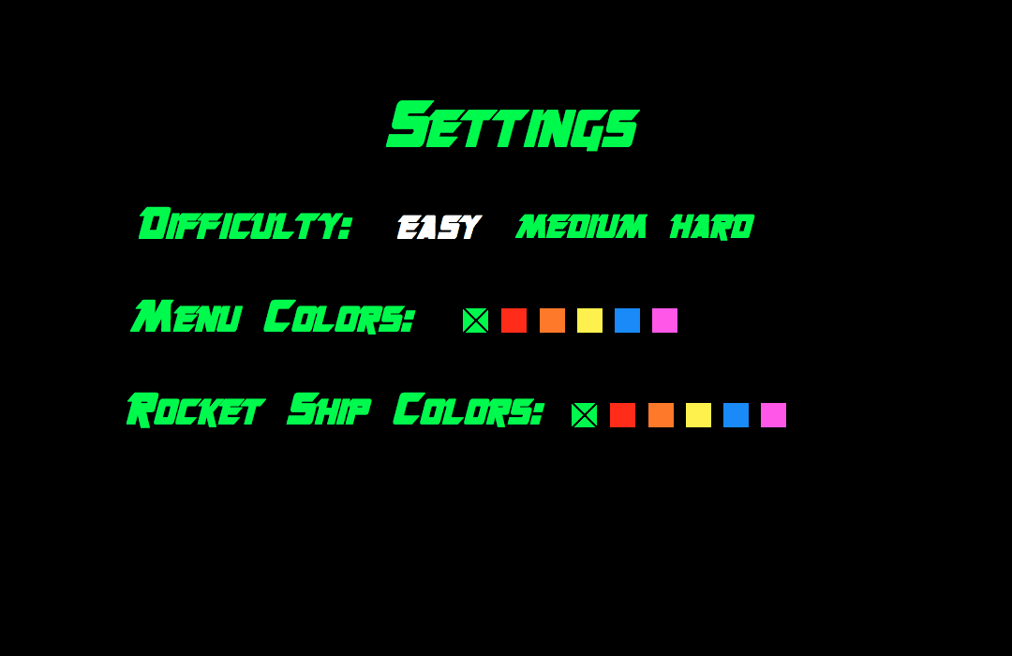
These are screenshots of the buttons after clicking happens. Note that no high score is available because no one has earned a spot on the scores, and the map that is currently generated is of a single tone song.

[Settings Menu]
Summary:
This screen will be the menu that customizes our game. It contains various buttons that can be toggled, so the user can have a more customizable and personal experience when playing the Great Audio Race. The options that can be selected are Difficulty, Menu Colors, and Rocket Ship Colors. The user has the ability to toggle what difficulty setting and what personal game colors that the individual will enjoy.
Detailed Information:
The Settings Menu is a file that is called upon by the MainGame.py method. When this screen is called for, there will have 3 different options to choose from, with multiple buttons to toggle. The player has the options of Difficulty, Menu Colors, and Rocket Ship Colors. Whether it is the player, or a therapist or doctor, or even the player’s parents, the options can be customized to have the best experience possible.
As the player clicks the Settings button they will be brought to a screen (pictured on page 5) with a list of customizable options for them to select from. They can select the difficulty of their game, this being the speed of the game, the amount of obstacles, as well as life total. The buttons that can be toggled are Easy, Medium, and Hard. When the level of difficulty is selected, the button will have a white font, while the other difficulty buttons will appear as the menu colors.
The player next has the option to select the Menu Colors. This allows the player to choose a favorite color for the menu layouts. There are at total of six colors to choose from, and the default color is green. When a color is changed, all of the titles and words will change to the preferred color.
The last option is the Rocket Ship Color. The player can make the rocket ship, which will be controlled in the game by the player, a preferred color. Again, the player will have a variety of six colors, and the default color for the rocket ship is green. The whole ship does not change colors, and it is the main solid body of the ship that has a change in color. The flame from the ship and the cockpit do not change in color.
This menu is one of the most important aspects to The Great Audio Race. It is vital for the player to have a variety of available customizations. The colors range from many different colors, and it will be very useful for making a custom game. The many options add a more enjoyable and rewarding experience for the main player.

